**If-then scripts**

**Check the variable**

#!/bin/bash

Count=100

If [ $count -eq 100]

Then

echo count is 100

else

echo count is not 100

fi

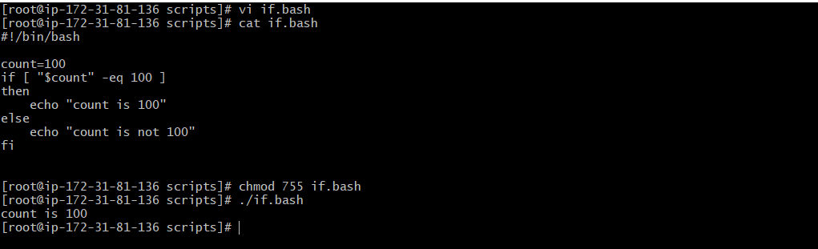

**Check if a file error.txt exist**

#!/bin/bash

Clear

If [ -e /home/aiesha/error.txt]

Then

echo “file exist”

else

echo “file does not exist”

fi

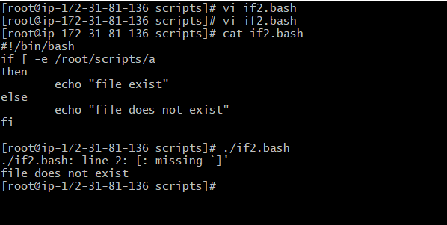

**Check if a variable value is met**

#!/bin/bash

a= ‘date |awk ‘{print $1}’’

if [ “$a” == Mon ]

then

echo Today is $a

else

echo Today is not Monday

fi

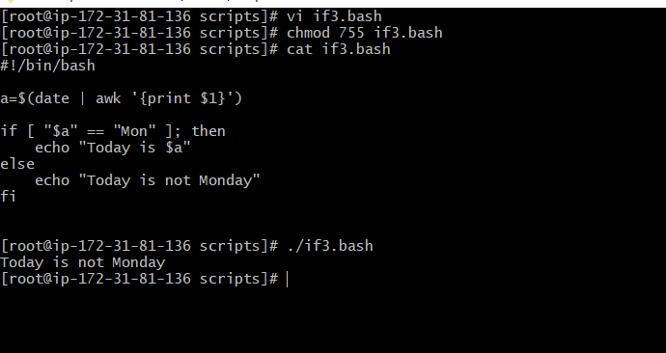

**Check the response and then output**

#!/bin/bash

Clear

echo

echo “what is your name?”

echo

read a

echo

echo Hello $a

echo

echo “do you like working in IT? (y/n)”

read like

echo

if [ “$like” == y ]

then

echo you are cool

elif [ $like” ==n ]

then

echo you should try IT, it’s a good field

echo

fi

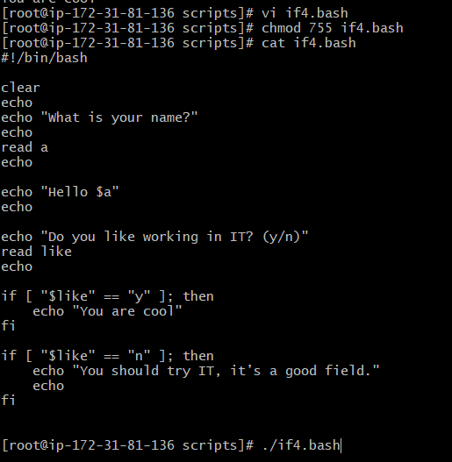

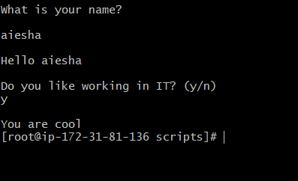

**Other if statements**

If the output is either Monday or Tuesday

If [ “ $a” =Monday ] || [ “$a” =Tuesday ]

Test if the error.txt file exist and its size is greater than zero

If test -s error.txt

If [ $? -eq 0 ] if input is equal to zero (0)

If [ -e /export/home/filename ] if file is there

If [ “$a” != ””] if variable does not match

If [ error_code != ”0” ] if file not equal to zero (0)

**Comparisions**

-eq equal to for numbers

== equal to for letters

-ne not equal to

!== not equal to for letters

-It less than

-le less than or equal to

-gt greater than

-ge greater than or equal to

**File operations**

-s file exists and is not empty

-f file exists and is not a directory

-d directory exists

-x file is executable

-w file is writable

-r file is readable